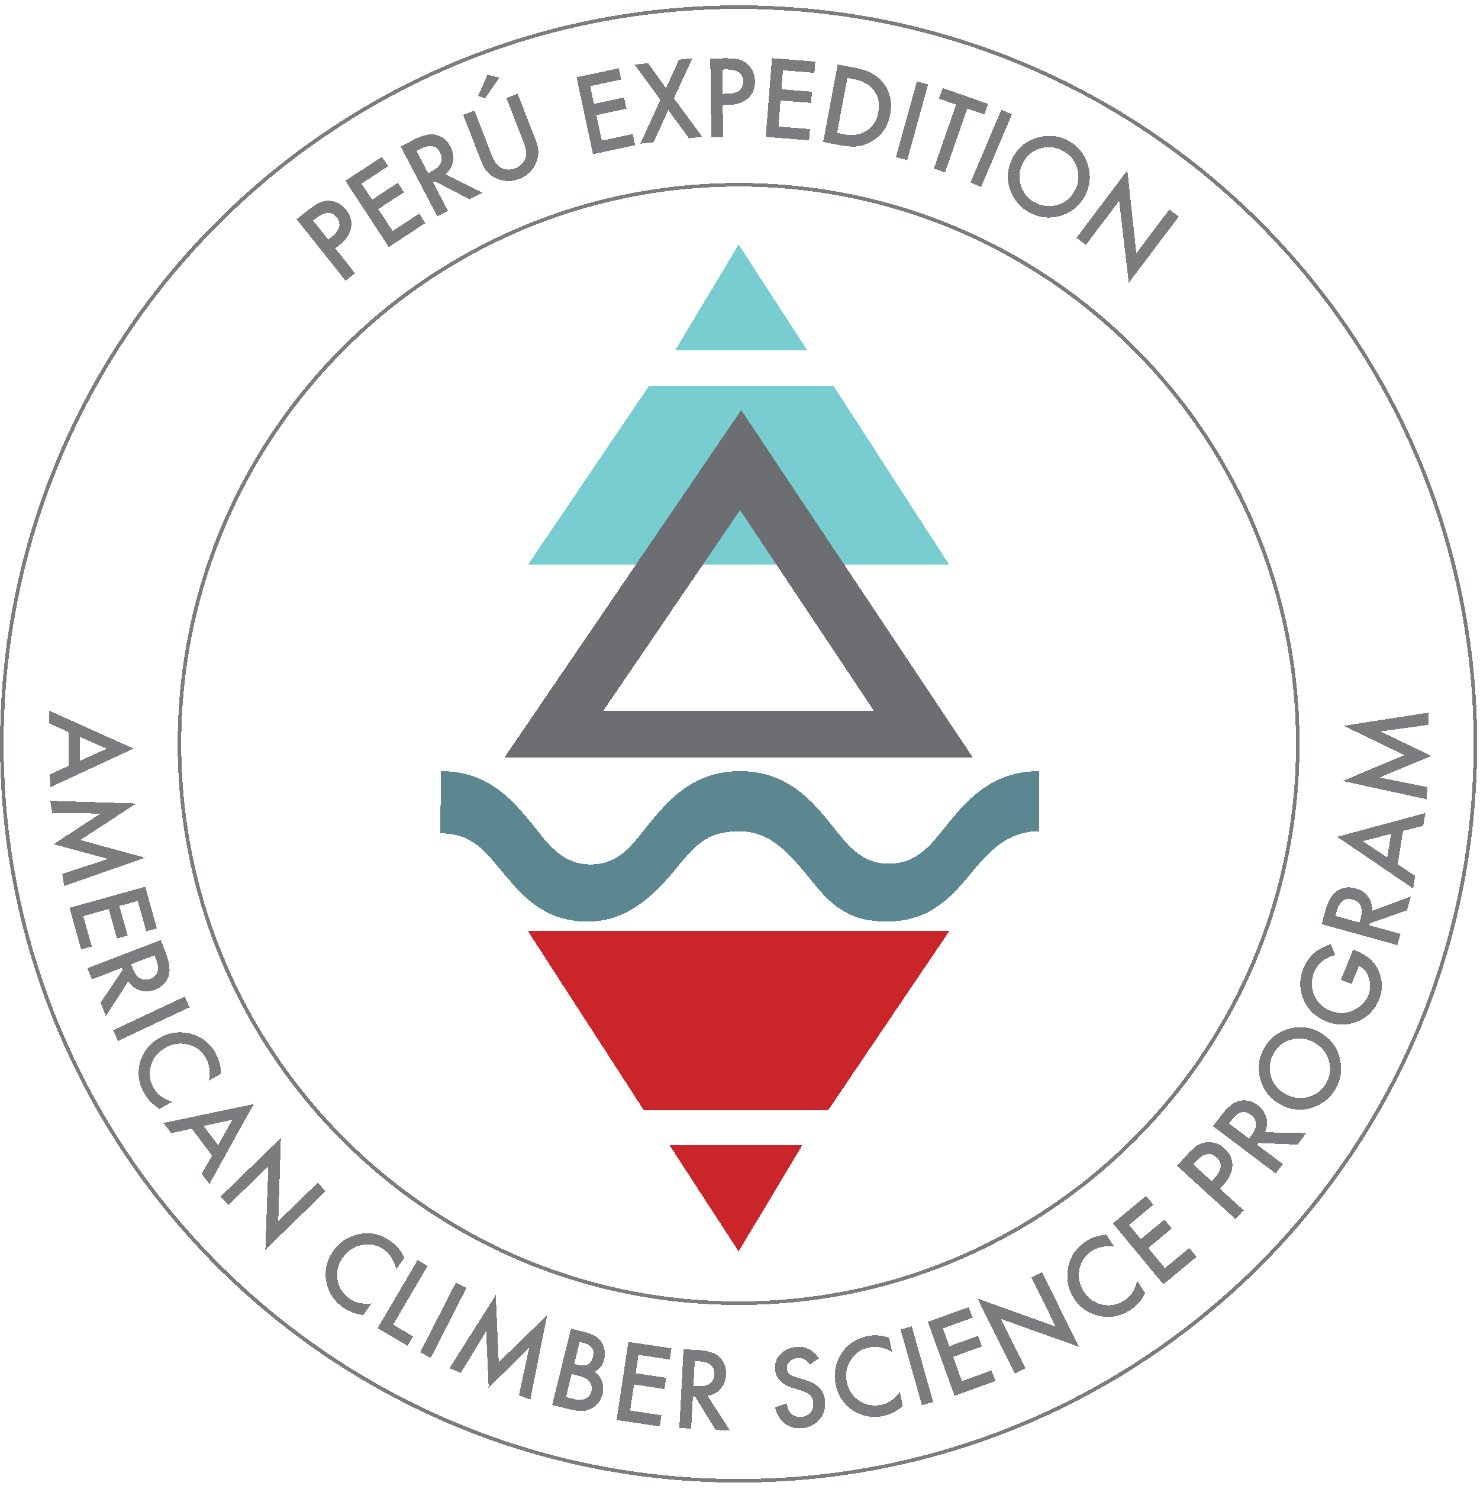
American Climber Science Program
Expedition Application

Send applications to:
ACSP Executive Director John All
Email: climberscience@gmail.com

Note: Applications will be considered in the order received.
Payment timing: A deposit of $500 is due with each application and is only refundable if you are not chosen for the expedition. The first half of the payment is due six weeks before the expedition. The remainder of the costs are due two weeks prior to the expedition.
Upon acceptance, we will need a copy of your passport photo page and a copy of your medical insurance information. All expedition members are required to join the American Alpine Club in order to get expedition rescue insurance or else provide their own Rescue and Extraction insurance.

INSTRUCTIONS: Fill out all items highlighted in yellow. Read all item highlighted in green.

Trips and Dates Requested: – Please indicate which Expedition or for Expeditions with more than one Trip like Peru, please indicate which Trip you want to do. For more information regarding each Trip as currently proposed, see the Expedition Schedule (http://climberscience.org/).

Trip: | Requested? (Check)

Research/conservation project role
Research role | Description | Check one category
Researcher | Leading a research project
Student participant | Will participate in but not lead research
Volunteers | Will assist general expedition projects

Contact Information: (Some details are required by local Governments for our research permits).

Applicant Name (as on Passport):
Preferred Name:
Mailing Address:
Home Phone:
Cell Phone:
Email Address:
Skype address:
Emergency Contact Name:
Emergency Contact Phone:
Emergency Contact Email:
Passport Number
Passport Country:
Birthday:
Professional Affiliation:
AAC Member Number:
AAC Section Affiliation:

Experience and Skills: This information helps us to better plan our expeditions. Prior backcountry, medical, and climbing experience (except for high-mountain research participation) are not required to join an expedition.

Camping and backcountry experience: Please describe your backcountry experience.

Science/Conservation Project Experience: Please provide a description of your research or conservation volunteer experience.

Mountaineering Experience: This is for volunteers wishing to assist high-mountain research. Please include mountain/route name, location, highest elevation, and year - and please be most detailed about your climbing over the past few years. Include (in order of importance) expedition mountaineering, alpine ice, ski mountaineering, alpine snow, multi-pitch ice, and multi-pitch rock climbing.

Medical Experience: Please provide a description of your medical training.

GENERAL INFORMATION: Please visit our website or contact us for more information.

Payment timing: A deposit of $500 is due with each application and is only refundable if you are not chosen for the expedition. The first half of the payment is six weeks prior to the expedition. The remainder of the costs are due two weeks prior.
Payments, including the initial deposit, should be made to the American Climber Science Program online through PayPal: http://climberscience.org/donate
The American Climber Science Program is an IRS 501(c)(3) Non-Profit Organization based in Colorado. Your generous donation makes our research, conservation, and education programs possible. Some or all of your donation may be deductible for federal income tax purposes - please consult your tax advisor.

Covered Costs: Note: the expedition begins at a designed city or town and participants are required to get to this location on their own. Please see expedition details at: (http://climberscience.org/).

Costs covered by your expedition fees potentially include:
National Park Research and Climbing permits
Accommodations in our initial meeting town (shared room with up to 4 people)
Expedition Cooks (depending on the expedition)
Expedition Food
Cook and dining tents (depending on the expedition)
Burro transport (when available)
Transportation to all trailheads
Group climbing gear (ropes, snow/ice protection)
Basic technical training to use the science equipment
Basic Medical Equipment
Emergency Satellite Communication (note: not for personal calls)

Costs NOT covered include:
Travel to and from the initial starting town
Food and personal activities in our base town
Individual porters, if needed
Individual climbing gear and clothing
Personal sleeping gear and tents
Tips for cooks and guides, if applicable
Passports, visas and vaccinations
Medical, hospitalization and evacuation costs

Scope of Participation:
The Expedition’s primary mission is the achievement of research and other science-related objectives. If you participate in the Expedition, you will be agreeing to participate in supporting the Expedition in its pursuit of its objectives, without regard to whether you participate in any particular activity. The scope of your actual participation in the Expedition may vary depending upon a variety of factors, including your skills, experience, physical conditioning and preparation, as well as your ability to acclimatize or otherwise adjust to conditions adequately. Note that you won’t be required to participate in any activity for which you don’t feel prepared or capable and you’ll be solely responsible for exercising your own judgment regarding whether to participate or continue participating in a particular activity.

Important Note About Preparation, Conditions, Safety & Risk:
Previous experience in high altitude locations and with the other activities described, as well as excellent fitness and a high tolerance for uncomfortable conditions, are essential for participation in High-Mountain Research participation. In specific:
- Climbing and engaging in other activities at high altitudes is inherently dangerous and there is no way to provide absolute protection.
- Possible dangers include avalanche, rock fall and crevasse fall.
- Medical conditions such as Acute Mountain Sickness, HAPE, HACE, blindness, etc., are all possibilities.
- Weather can be unpredictable and present great personal dangers of frostbite and death from cold conditions. Unpredictable weather may also lead to hypothermia and similar health-related risks.
- Although we will have a satellite phone with us, satellite phones are not always reliable. Even once contact with local authorities is made, any rescue response is likely to be slow at best.
These and other hazards require a high degree of competence, vigilance and care. This expedition is not a guided tour, expedition or holiday and is being led by volunteers who are not paid professional guides or leaders. All participants will be solely and fully responsible for their own safety. Participants are responsible for having the appropriate skills, fitness and supplies required for this endeavor and accept full responsibility for the inherent and other risks associated with the Expedition. More information regarding the risks involved in the Expedition are set forth in the Acknowledgment of Risk & Assumption of Responsibility available on our website. Please read this document carefully before agreeing to participate in the Expedition. It will apply to you if you participate in the Expedition.

Other Terms and Conditions:
A description of the General Terms & Conditions that will apply to the Expedition is available on our website. Please read them carefully, as they will apply to you if you participate in the Expedition.

